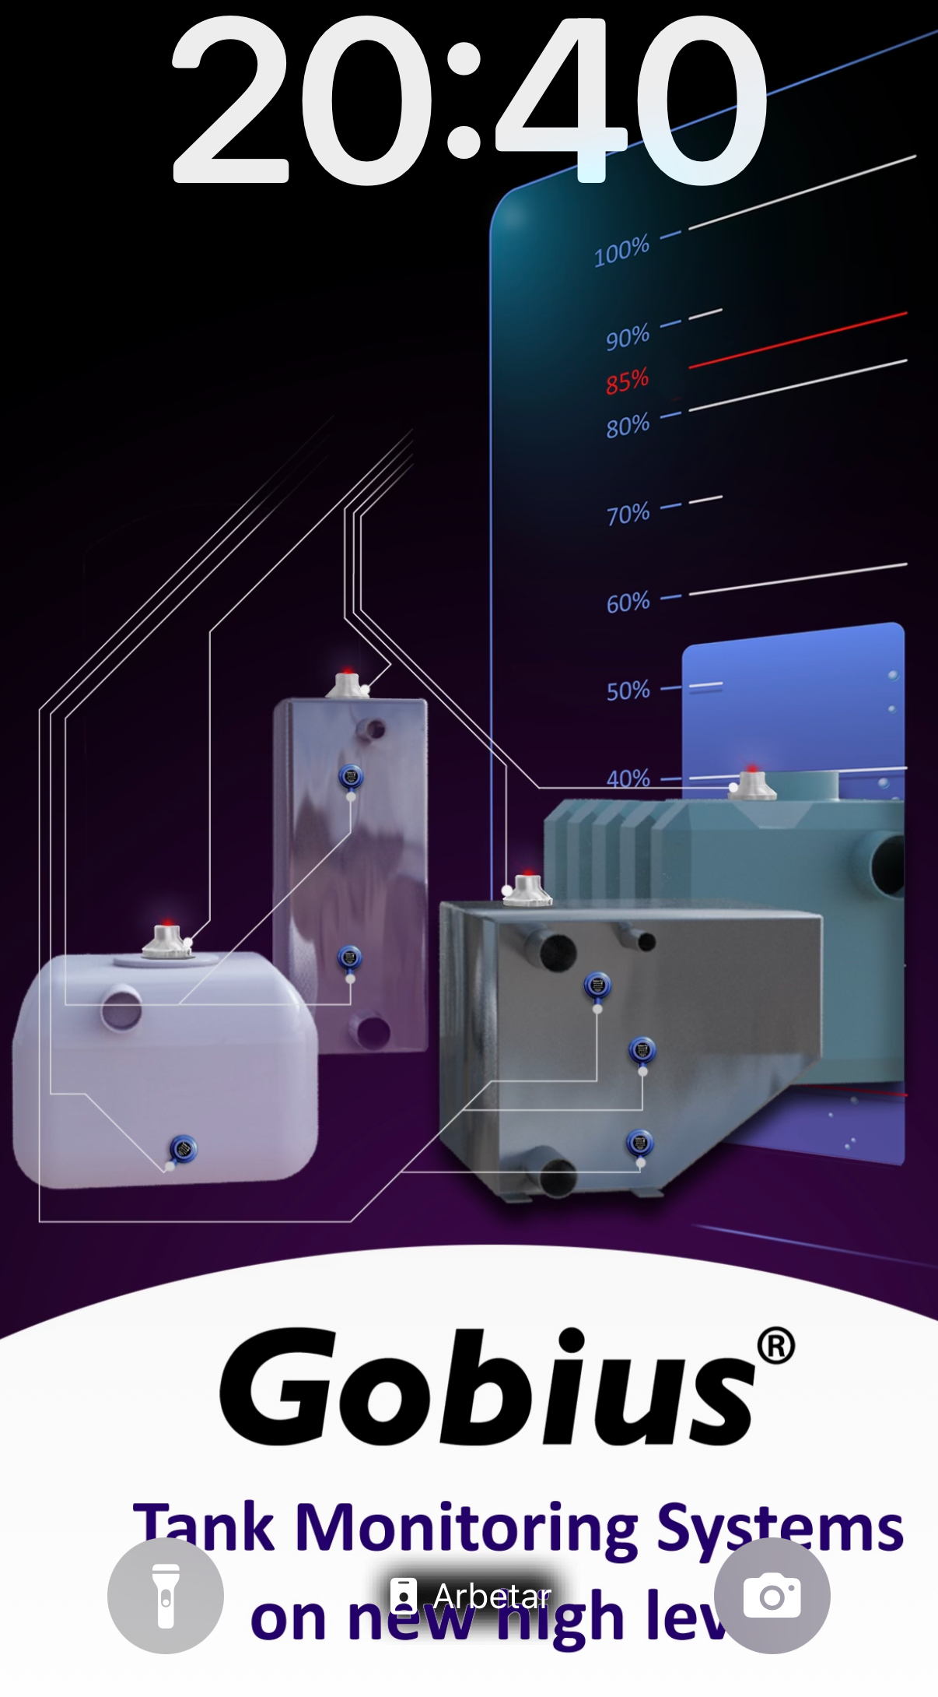
Hi,
This information is for you who want it in writing and not just on
your phone. You will receive the corresponding information when
you download the Gobius app, from Google Play and the App Store.
Table of contents
- 1 Before you install and config the sensor
- 2 In the box
- 3 Good to know
- 4 Installing the sensor on the tank
- 5 Sensor config in the App
- 6 Useful tips, product registration, news

1 Before you install and config the sensor

Download the Gobius App from Google Play or App Store.
Note: The first time you start the App, you will get a question
like, “Gobius Pro would like to use Bluetooth”.
Please answer “Ok or Allow”, Never “No or Don’t Allow”.
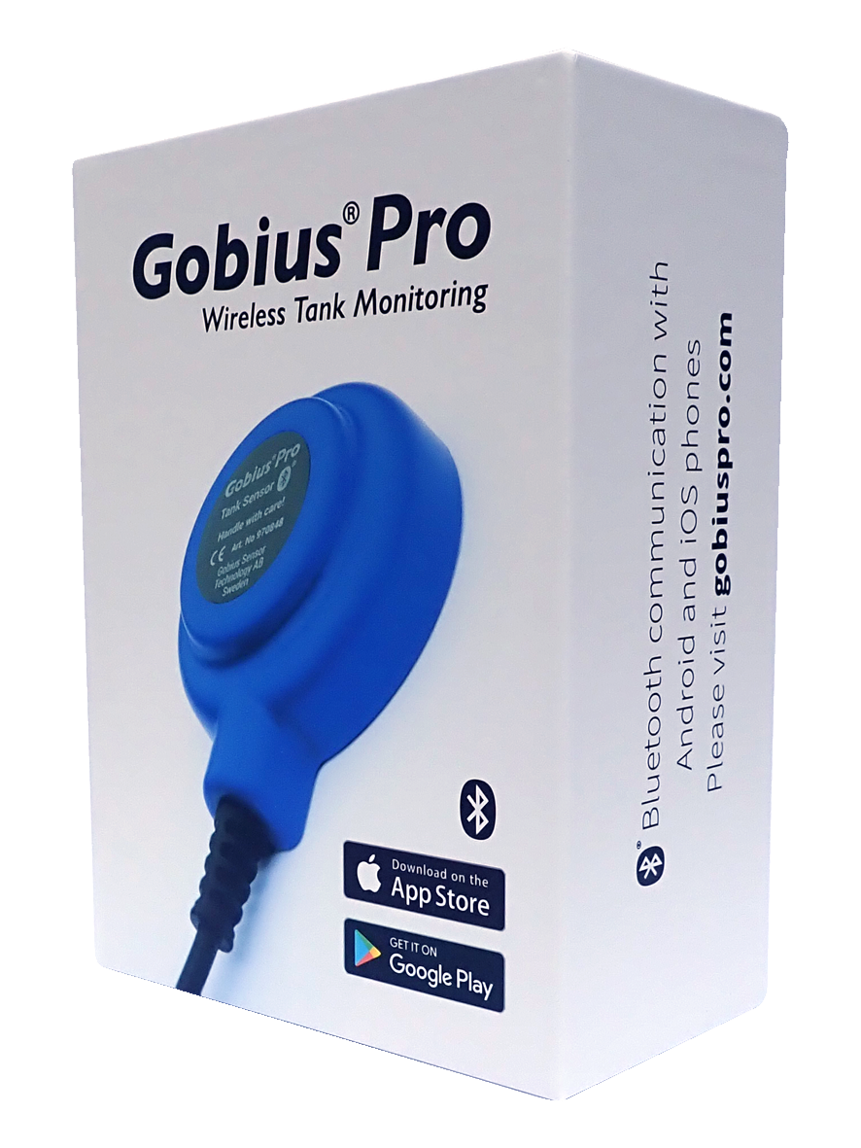
2 In the Gobius Pro box you get all:
- 1 Quick guide
- 1 sensor with 2 m cable
- 1 tank surface 3M Cleaner
- 1 extra 3M sensor tape
- 1 panel (the Gobius fish) with
red and green LED lights

3 Good to know
There are some important things you must consider before
mounting the sensor on the tank wall. You should check the tank wall
thickness. If it is thicker than the specification, Gobius Pro will not work.
- 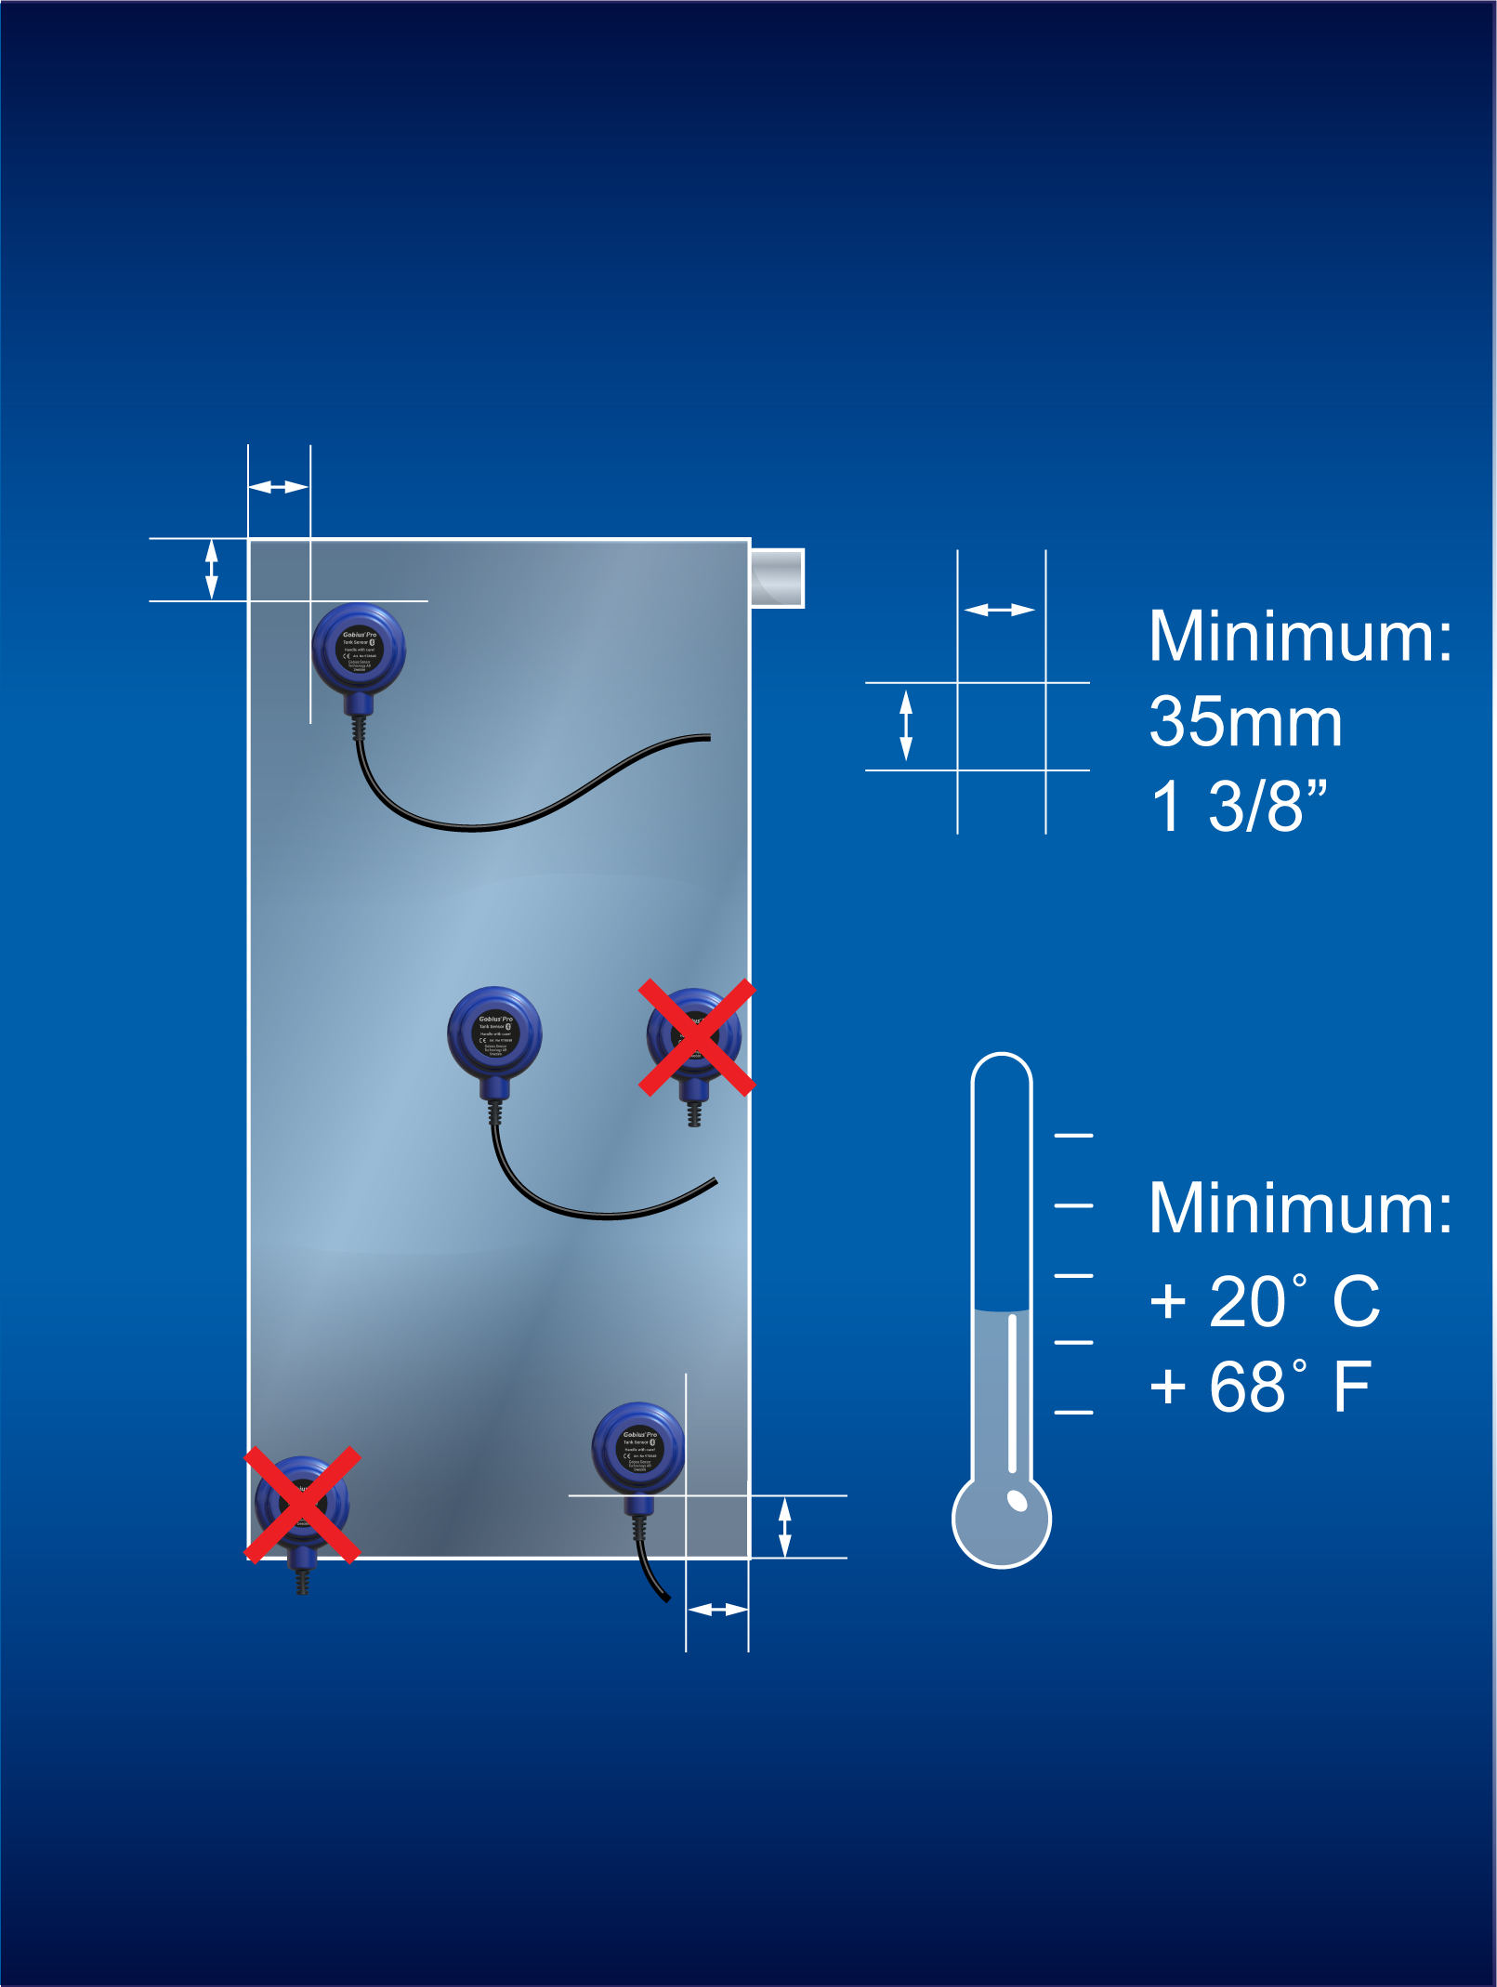Stainless Steel & Steel, max 3 mm
- Polyethelene, max 12 mm
- Aluminium, max 5 mm
- Fibre Glass, max 8 mm
3a
Do not put the sensor closer than 35 mm from an edge, or another
sensor and always on vertical sides.

3b
During installation, the tank wall temperature must be above + 20 C/68 F.
If it is below the sensor tape will not attach satisfying and there is a chance
that the sensor will fall off.
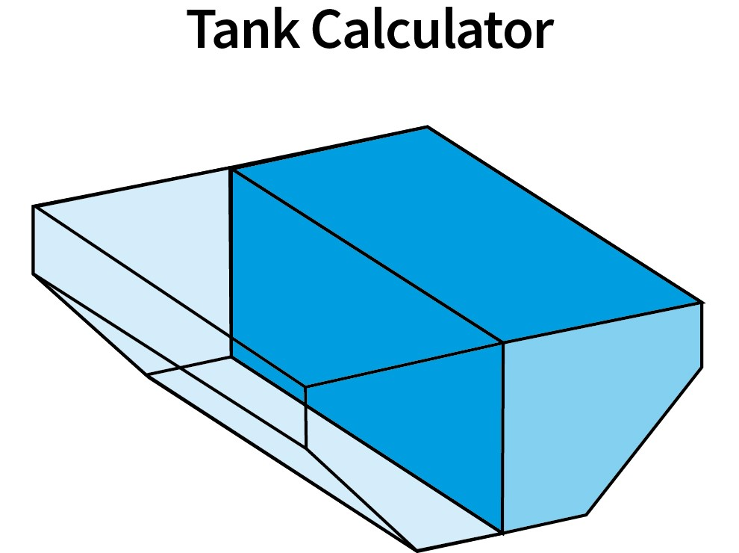
3c
A heat gun or a hair dryer can be useful when you need to heat up the
tank wall. After installation, the sensor will work between -10 C and + 60 C.
Never heat up the sensor tape.
3d
If you are going to install more than one sensor on one tank, you can start
with whichever one you want. In the app you tell what level (%) you have
placed the sensor. Repeat the installation again for the next coming sensor.
You can have a maximum of 9 sensors on one tank and the App can manage
several sensors on different tanks.
3e
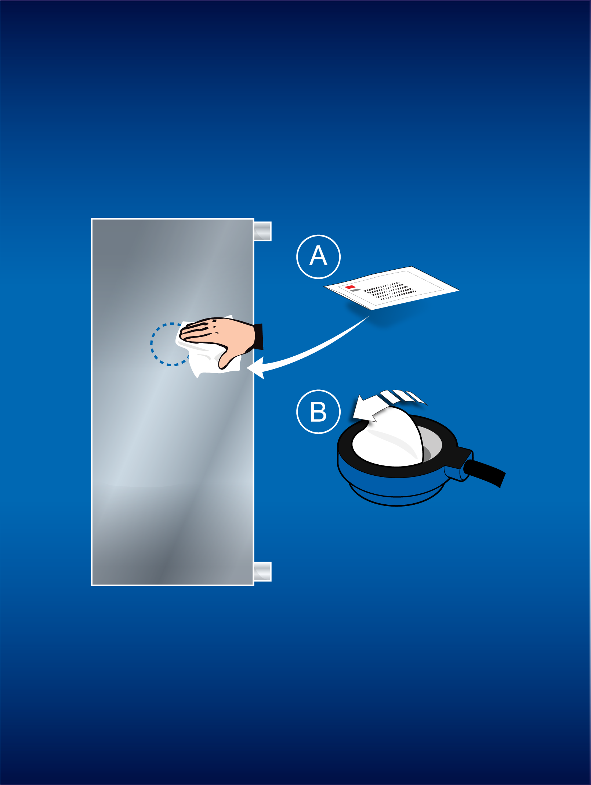When you have an irregular tank, you can use this tank calculator to calculate where to place your sensors to get the correct level. For example, if you have 3 sensors, you can choose levels 20%, 50% and 75%. You can also print out your tank calculation.
4 Installing the sensor on the tank
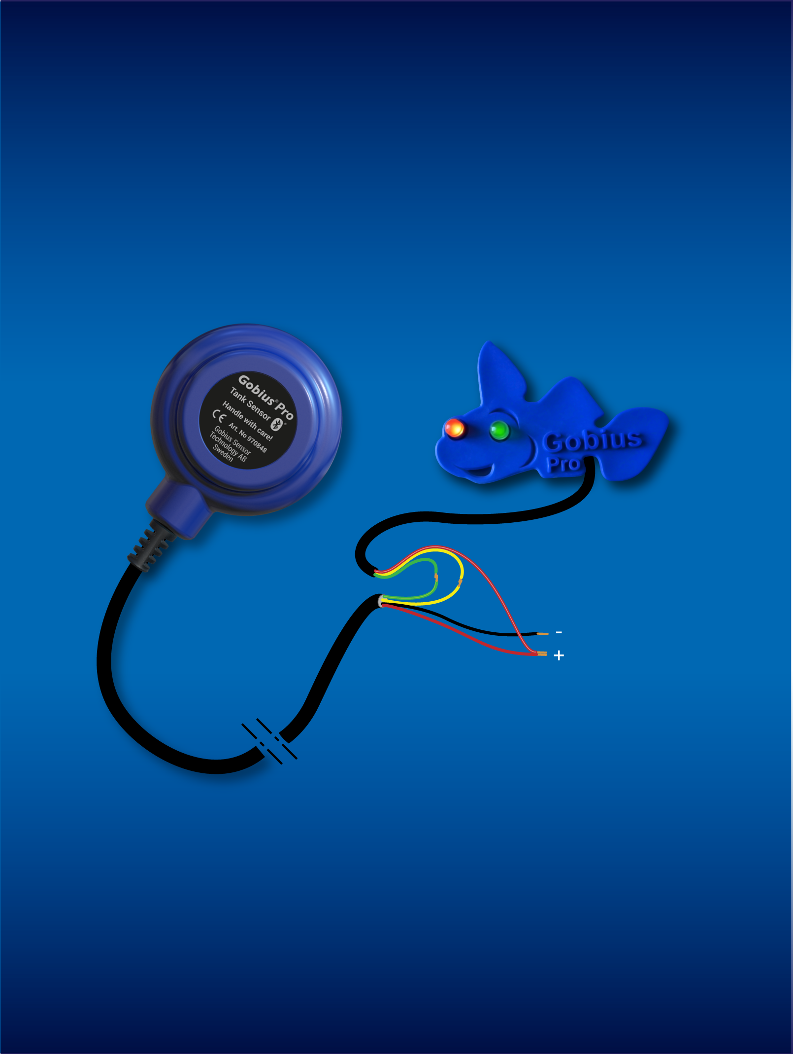Start with cleaning the place for the sensor. Please use the 3M Cleaner.
Check that the tank wall is not concave, where you want to place the
sensor. The temperature must be above +20 C/68 F. Peal the protective
paper on the tape and press firmly (hard) on the sensor for some seconds
and wait a few minutes before proceeding with next step.
4a
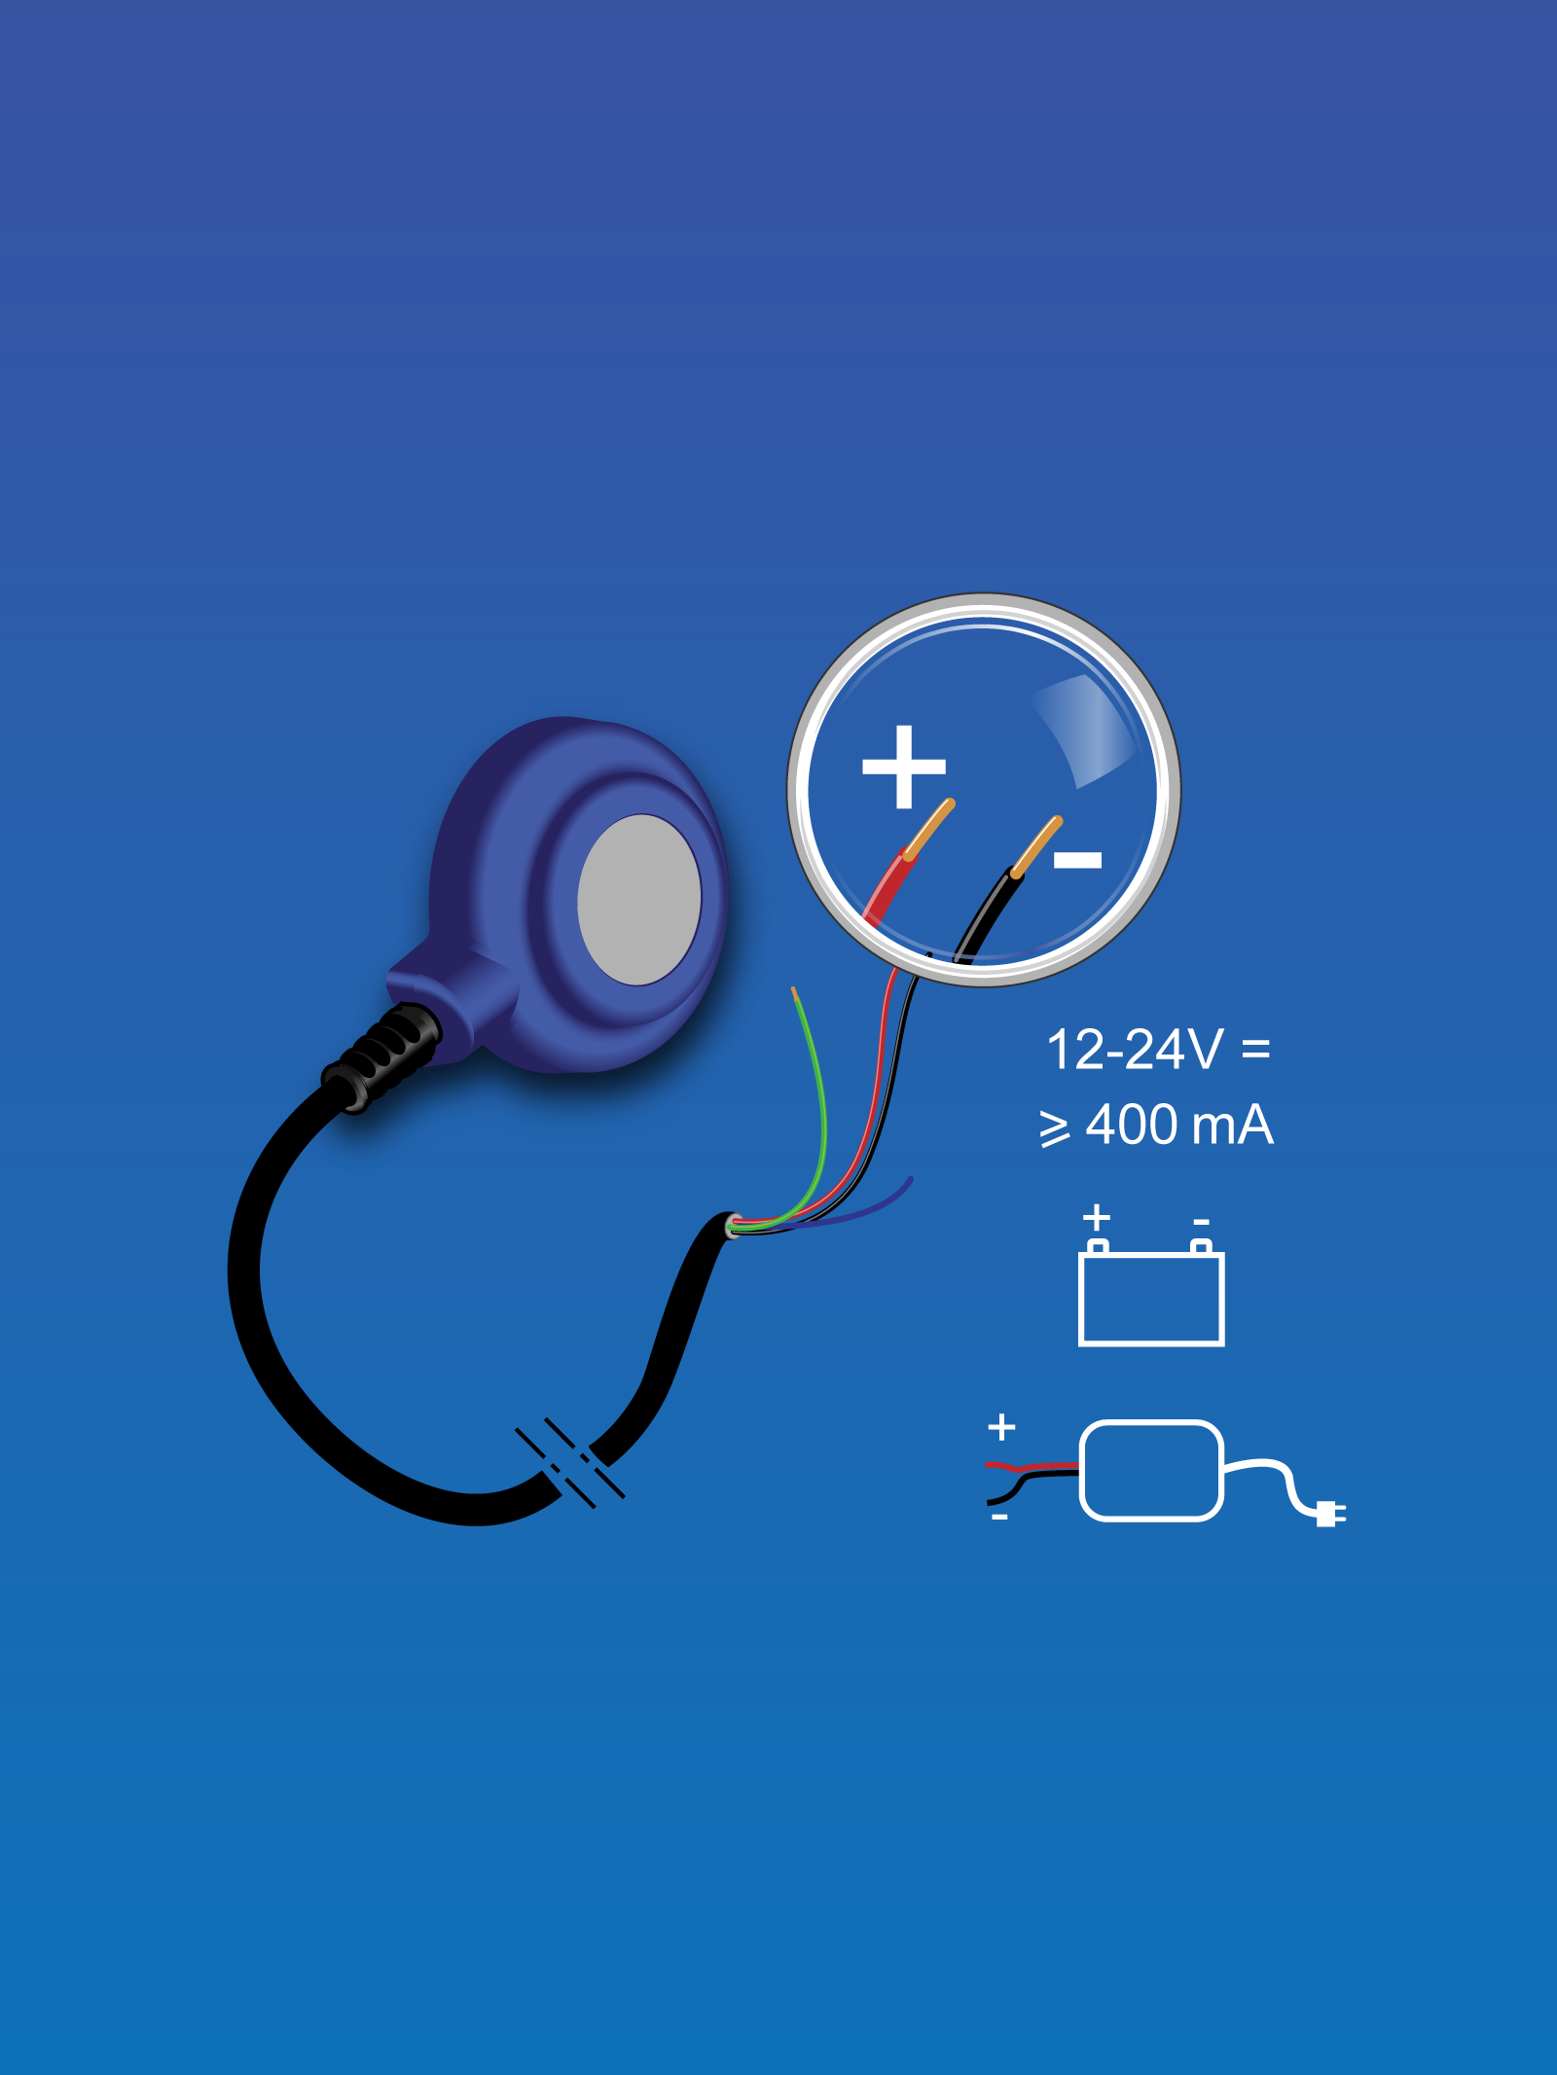Each sensor has two digital outputs, (On & Off signals). You can
connect the sensor as an alarm device to control systems, lamps/
buzzers or relays. Included in the package you have a “Gobius fish”
panel with two LEDs, red and green lights. See also point 10 and 19.
4b
Now it is time for connecting the sensor to the power, + is red cable
and - is black. The sensor supports 12-24 volts.
Note: If you connect the other way, nothing will be damaged.
Note: Your smart phone must have Bluetooth activated to get in contact
with the sensor. Please have a look in your phones Configuration.

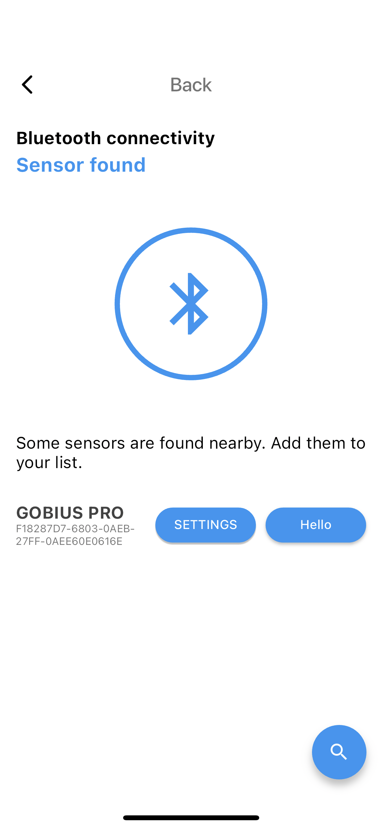
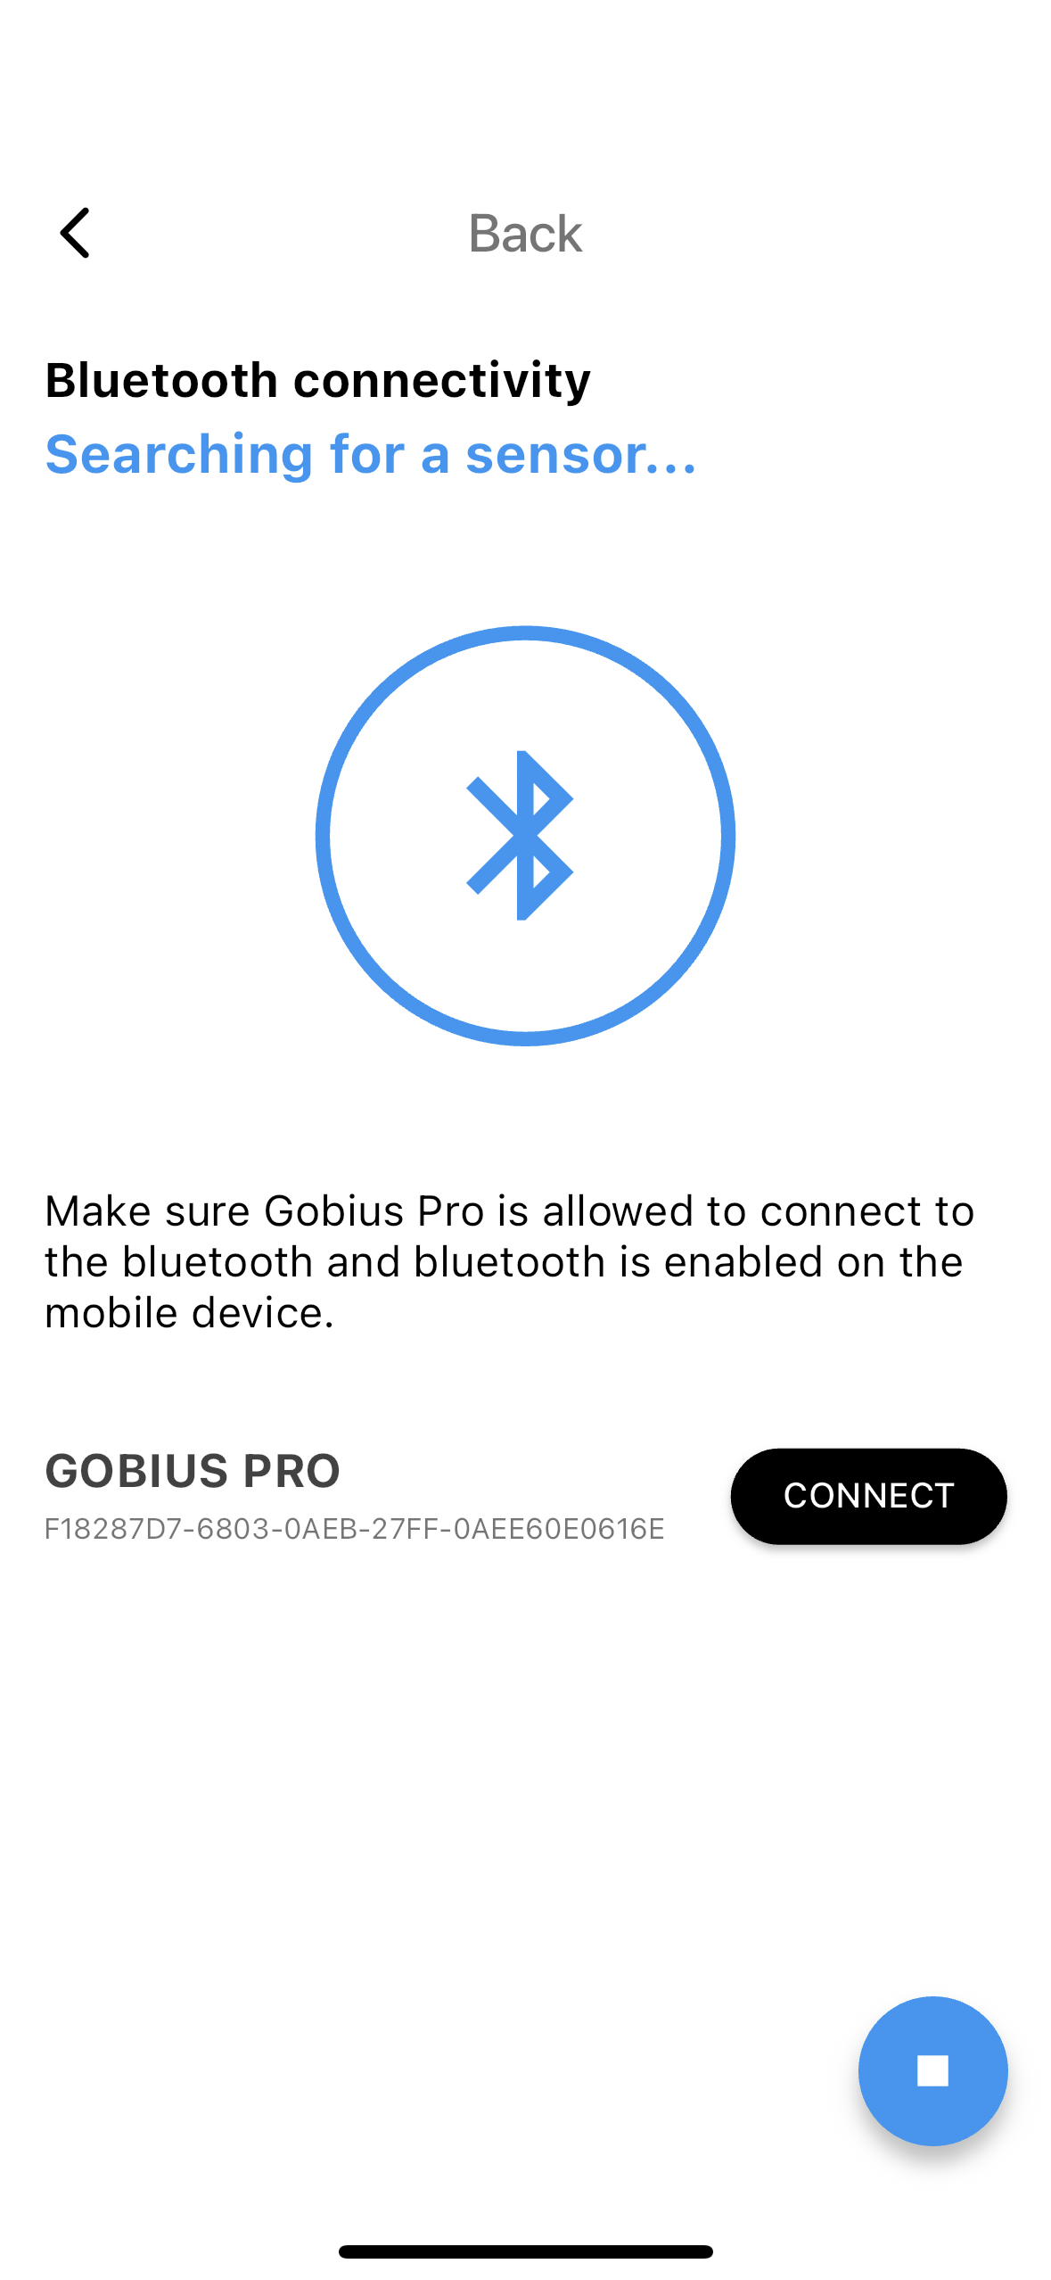
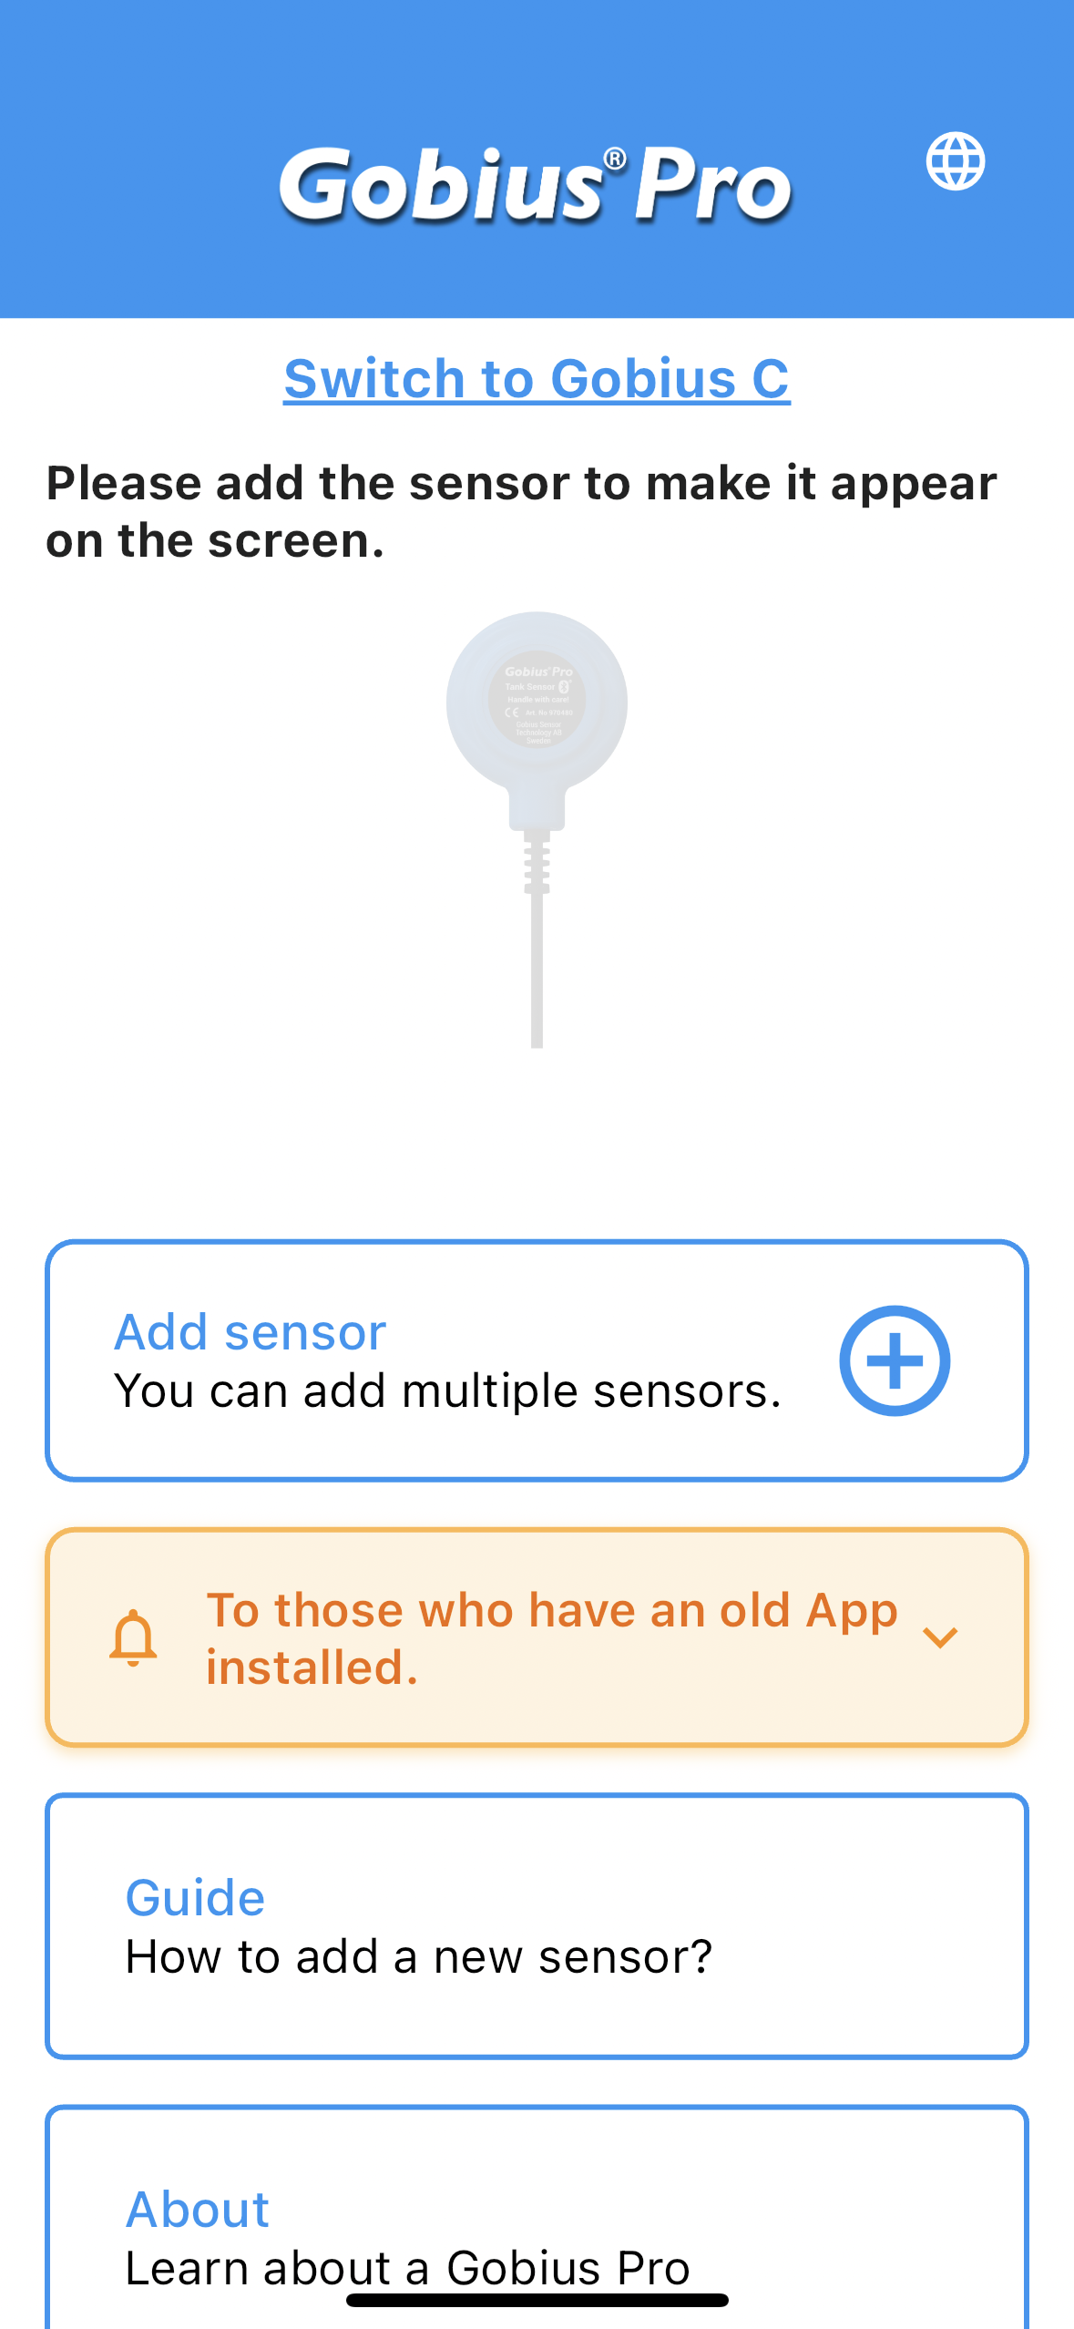
5 Setup in the App
Click on Add sensor. The Gobius App will
automatically find the sensor. You don’t
have to pair the sensor in your phone’s
settings. No code is necessary for pairing
the phone with the sensor.
The App is now searching for your sensor.
When the sensor is Bluetooth connected, you
can say “Hello” to the sensor. The sensor will
give back an audible signal. If you cannot get
in contact with the sensor, see note 1, above.
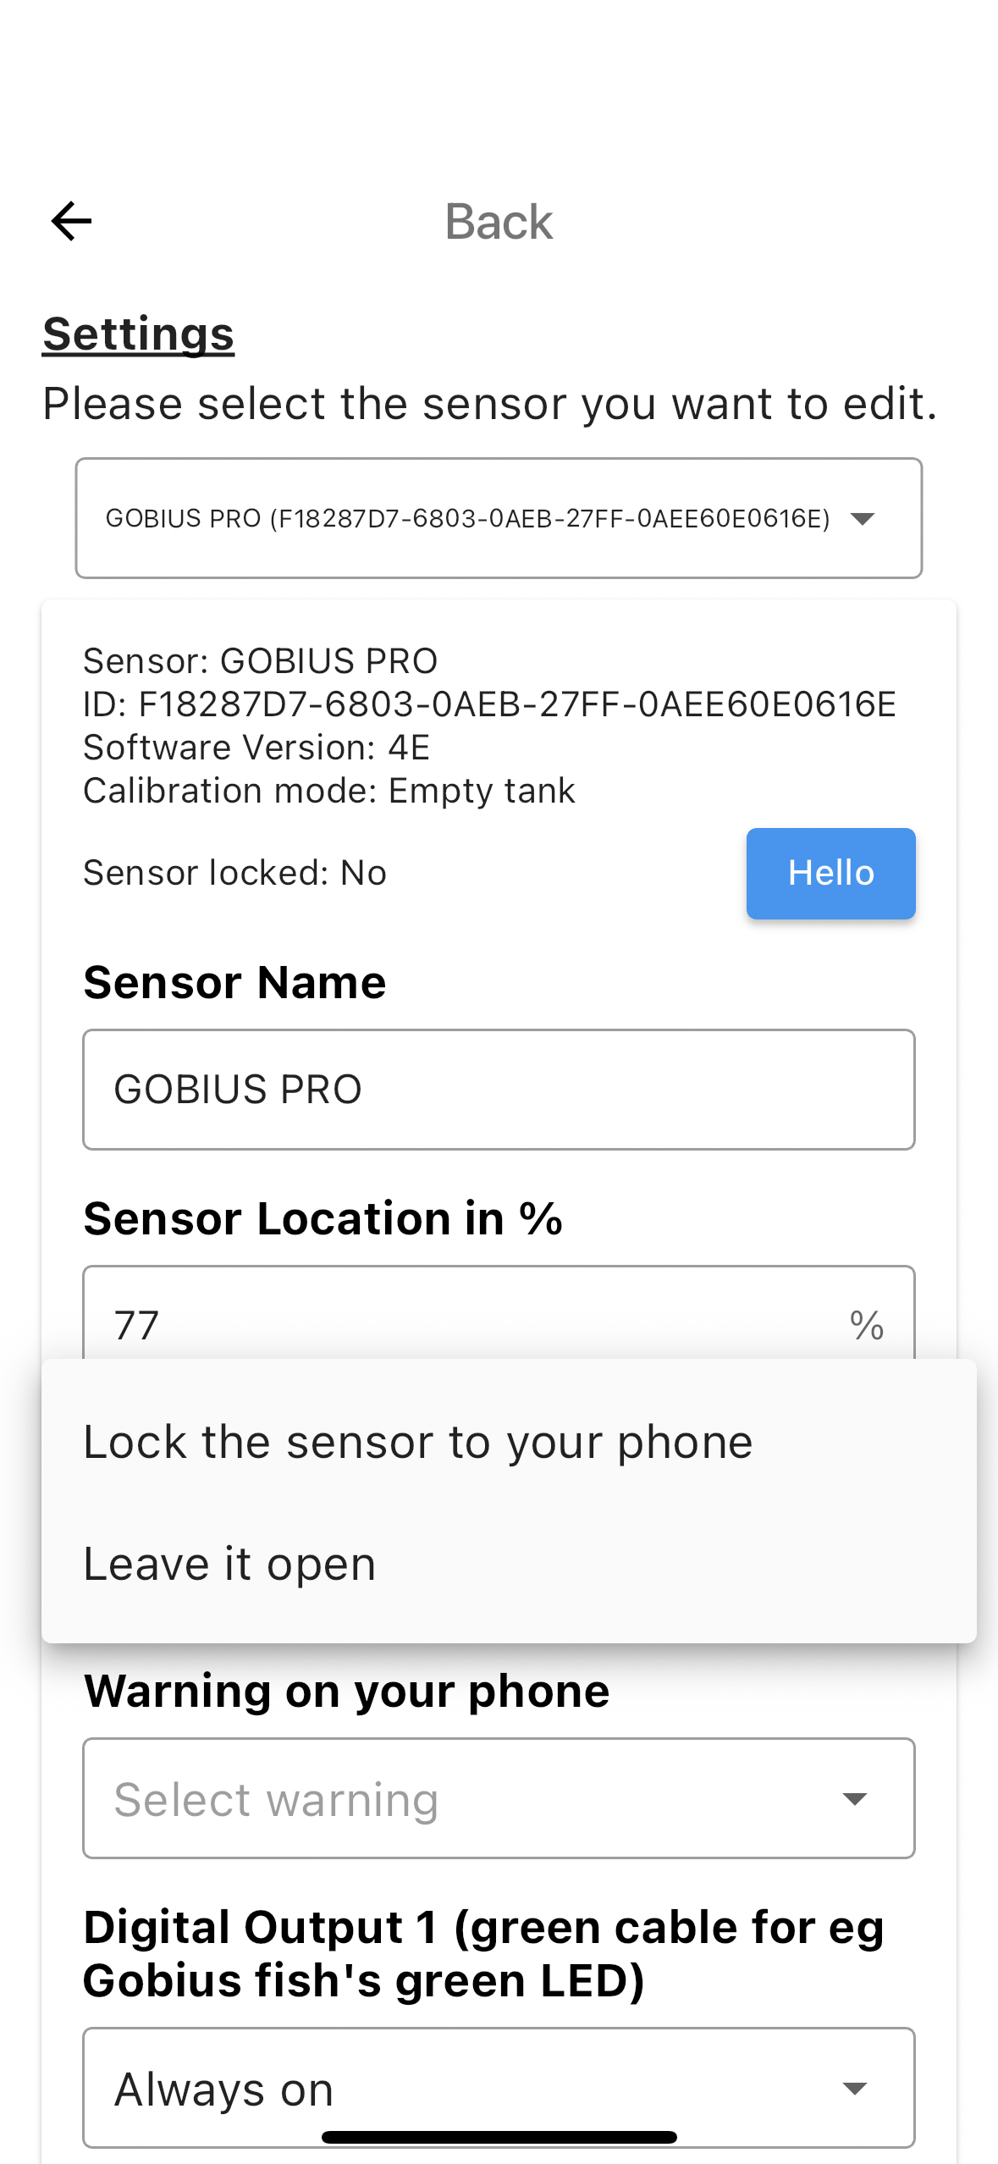
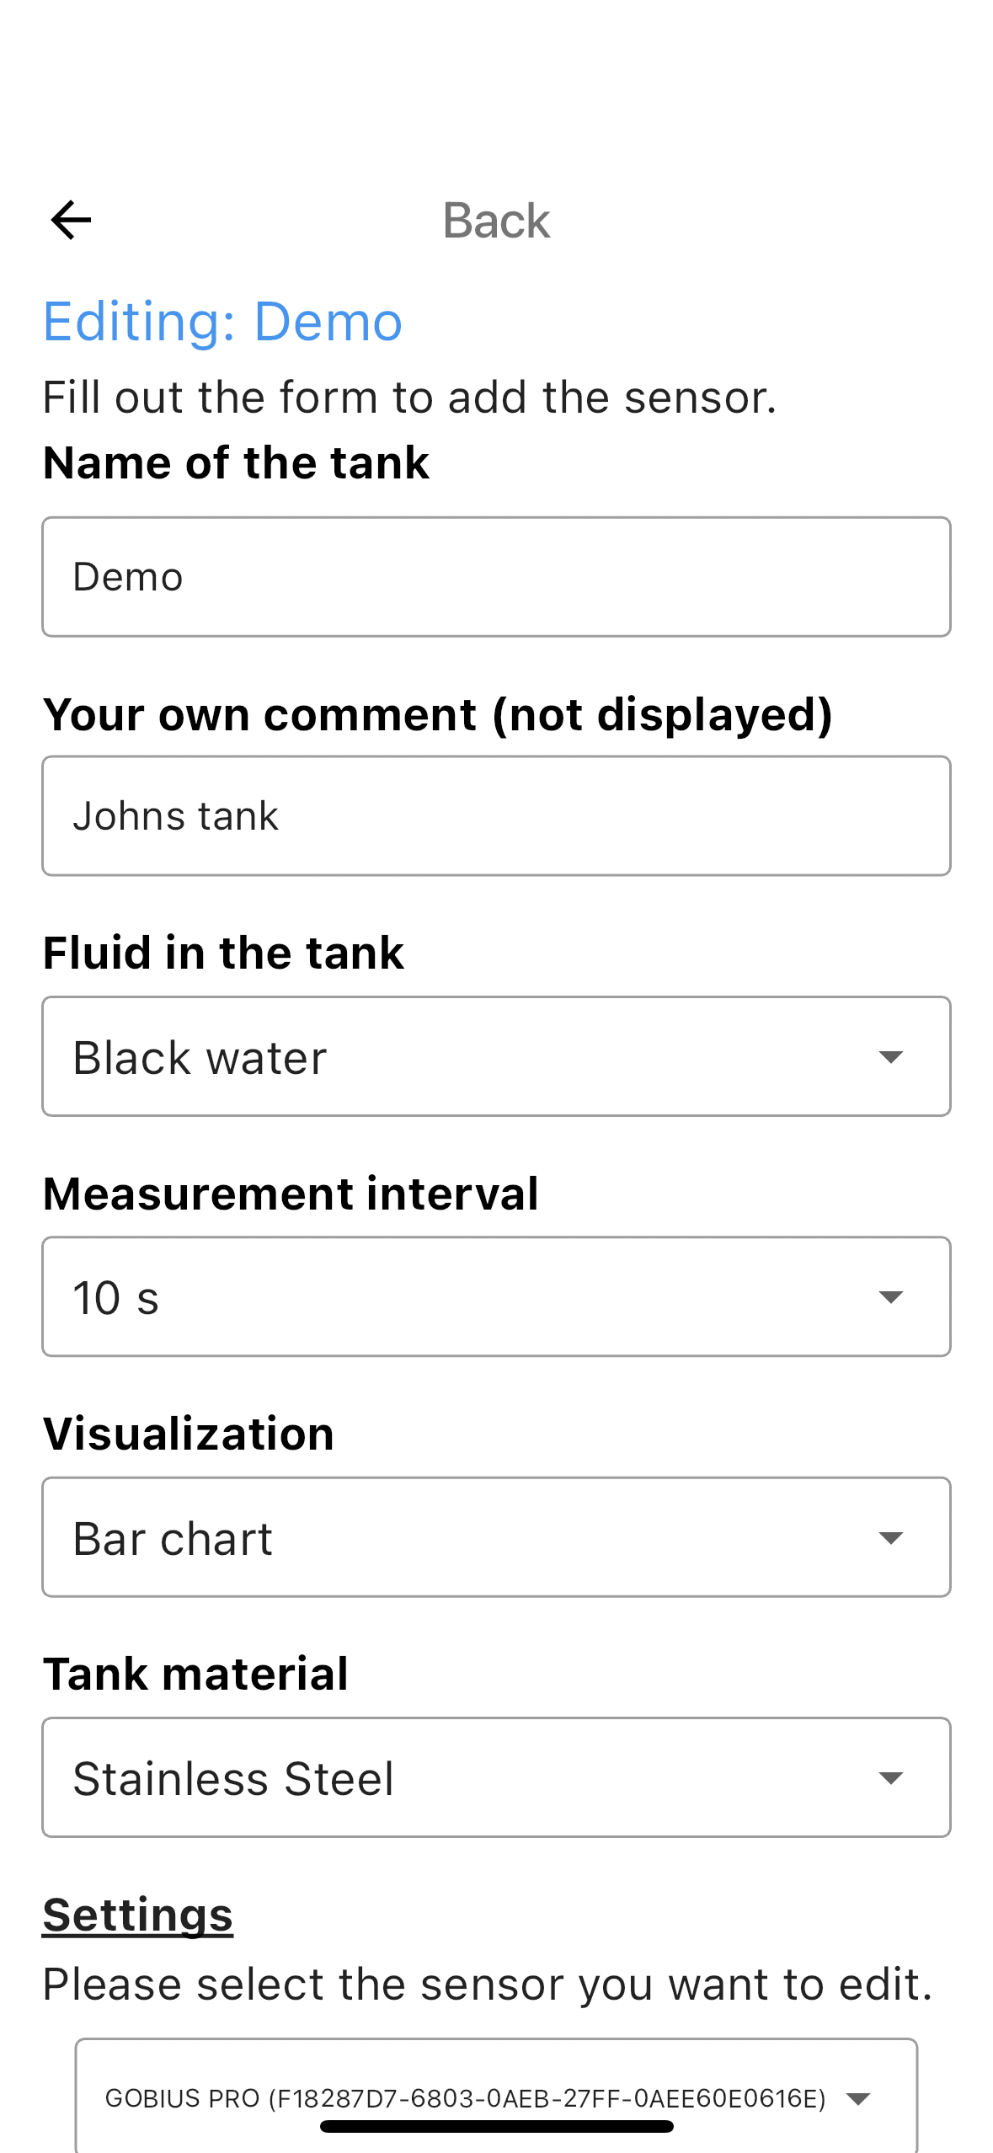
5a
Now it is time for configuration
- Give your tank a name
- Add your own comment
- Choose the fluid you have in the tank
  - Water
  - Fuel
  - Gas/Petrol
  - Gray water
  - Black water
  - Other fluid (oil based)
  - Other fluid (water based)
- Choose the measurement interval
  - 10, 30 sec
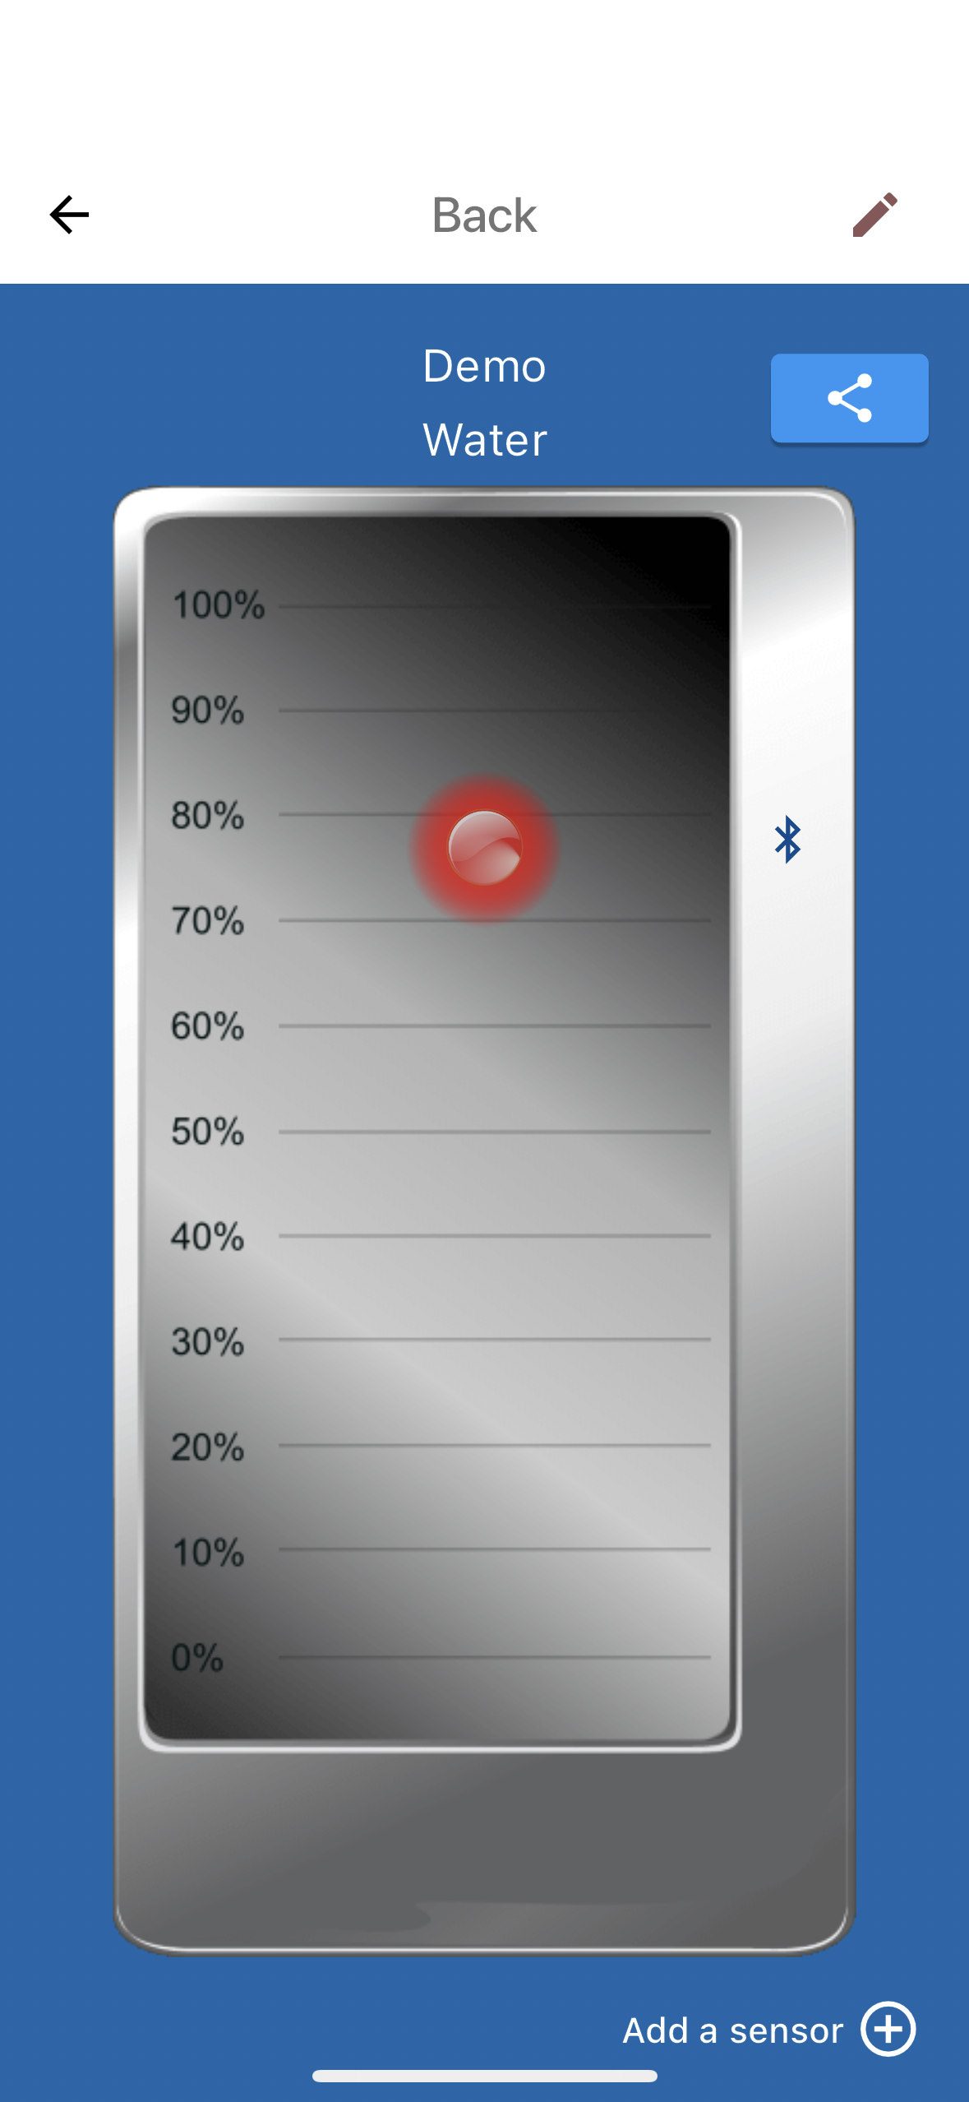
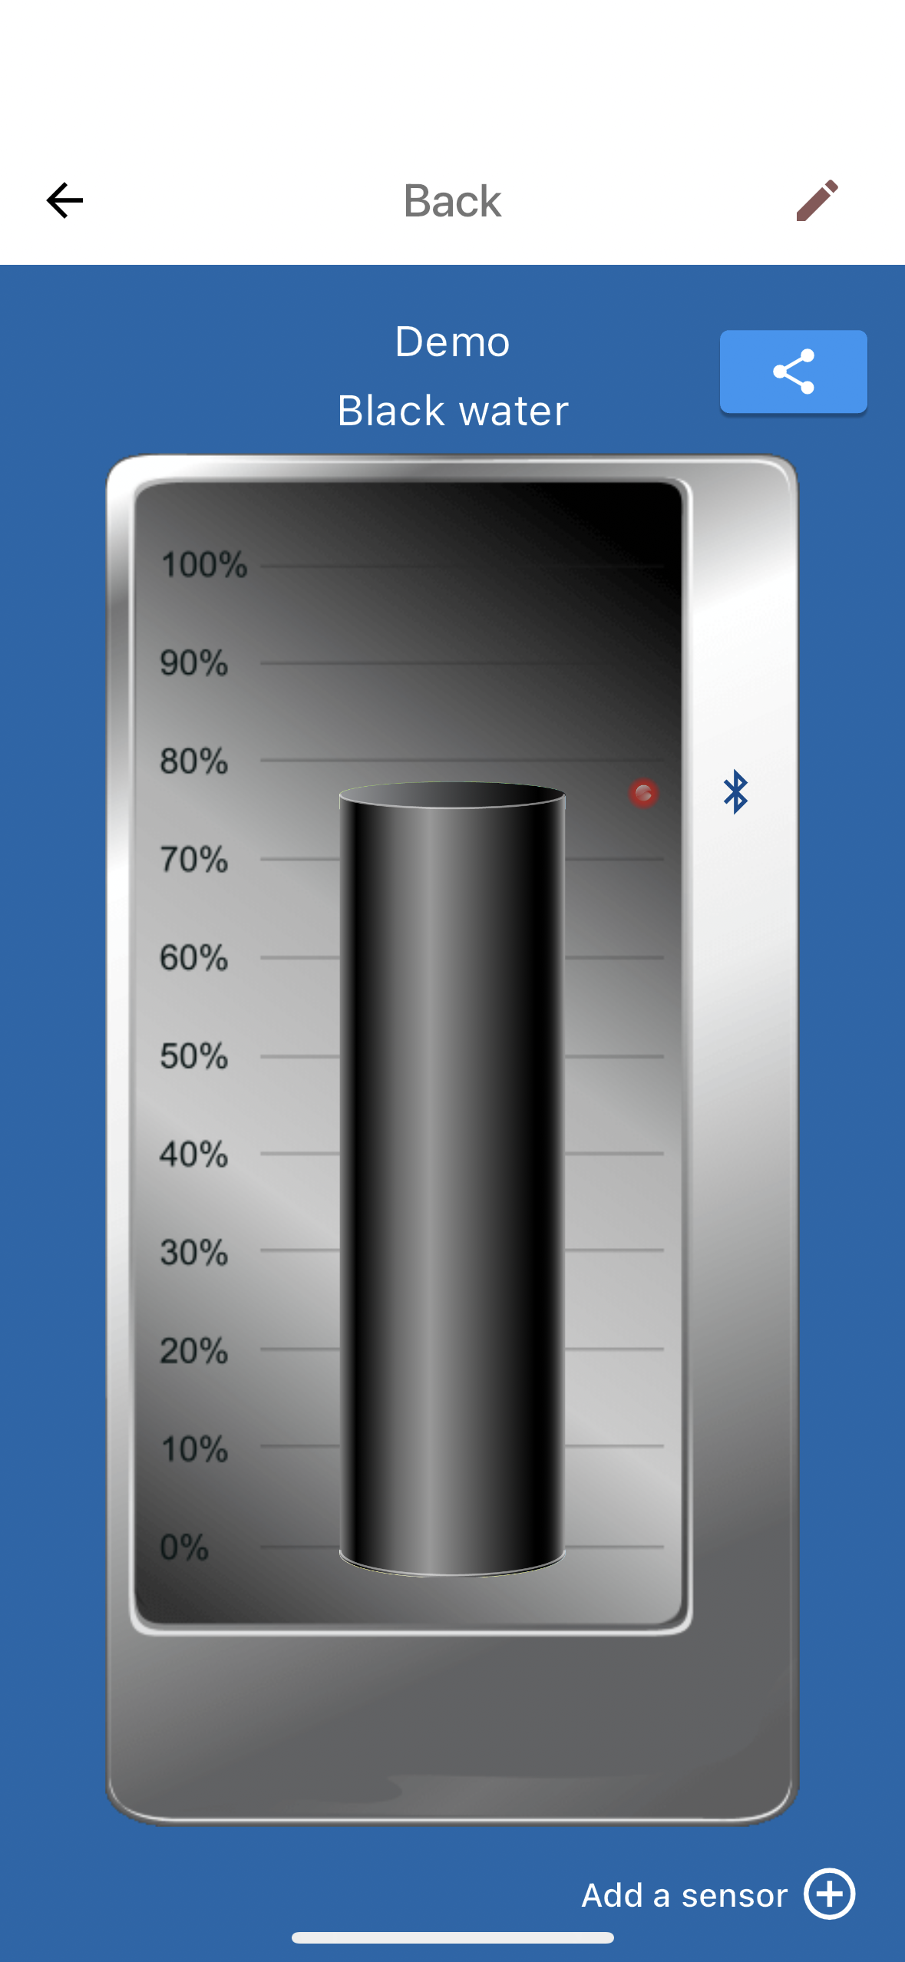
  - 1, 2 min
  - 1,4, 10 hours
- Visualization, choice your way
  - Point chart
  - Bar chart
- Enter your tank material
  - Polyethene
  - Steel
  - Stainless steel
  - Aluminum
  - Fiber Glass
- Give the sensor a name
- Sensor Location in %
Note: You can tell the app the exact position/level for the sensor.
- Security
  - Lock the sensor to your phone
  - Leave it open
Note: Here you can choose Leave it open to make your sensor
available to everyone, or you choose to Lock it to your phone,
i.e. the phone from which you do the installation.
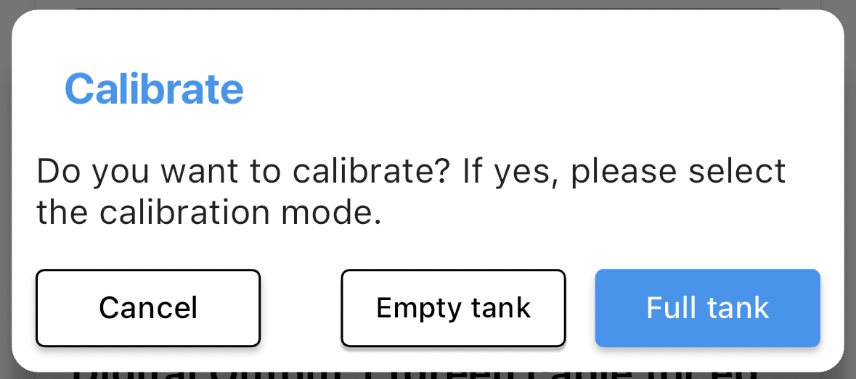
- Calibration mode
  - Empty tank
  - Full tank
Note: The fluid level can be above or below
the sensor when performing the calibration.

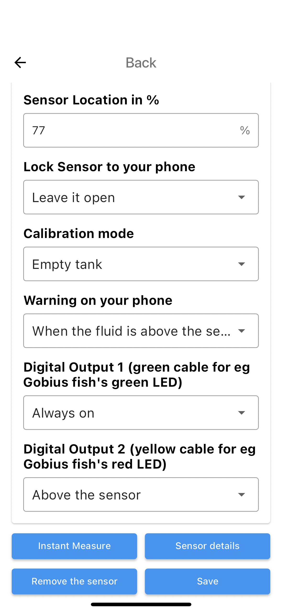
- Warning on your phone
  - Off
When the fluid is above the sensor
The point will turn red when the level is above
  - When the fluid is below the senso
Note: The point will turn red when the level is below

- Digital output 1, select (green and red cables)
  - Always off
  - Always on
  - On when the level is above the sensor
  - On when the level is below the sensor

- Digital output 2, select (yellow and red cables)
  - Always off
  - Always on
  - On when the level is above the sensor
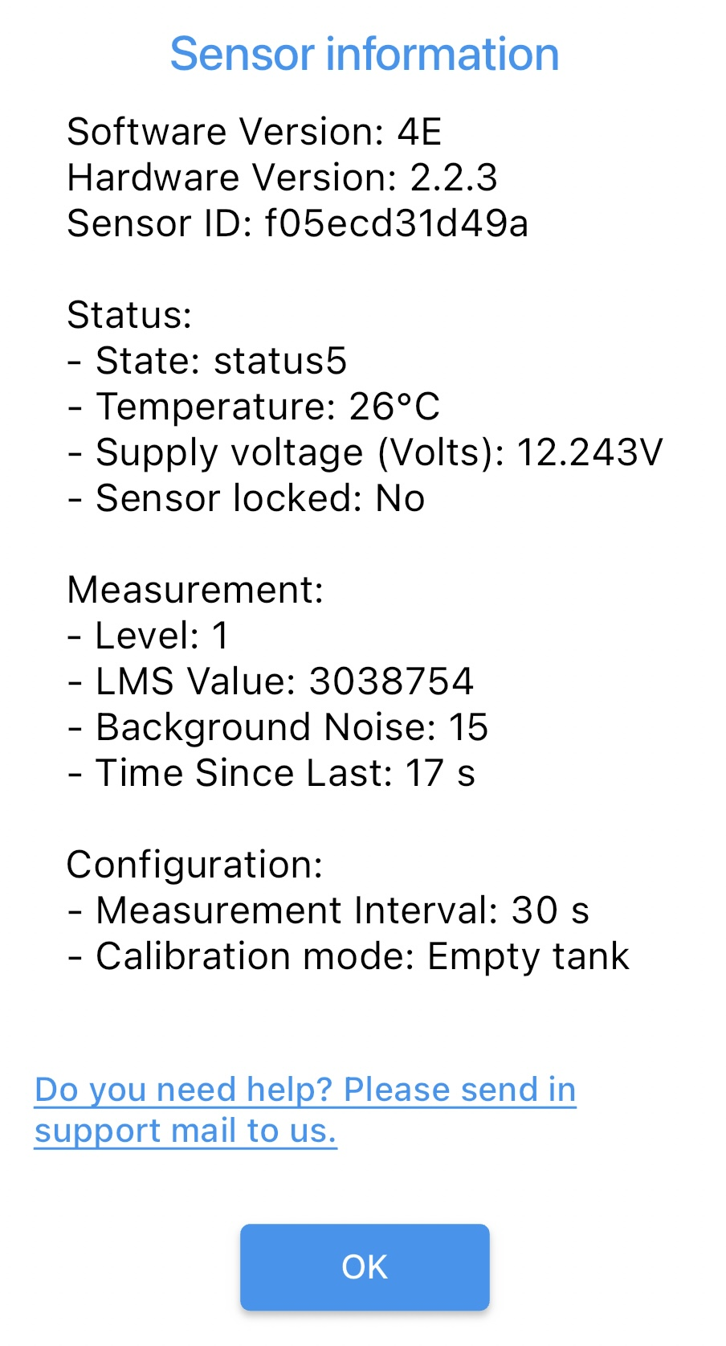
  - On when the level is below the sensor

5b
After performing this setup, you must go on with the Calibration.
It will take about 10 seconds. After that the Gobius is ready for you.

6 Useful tips, product registration, news
Sensor details, you get some facts about the sensor.
Note: This is also the place where you can send in a support mail.

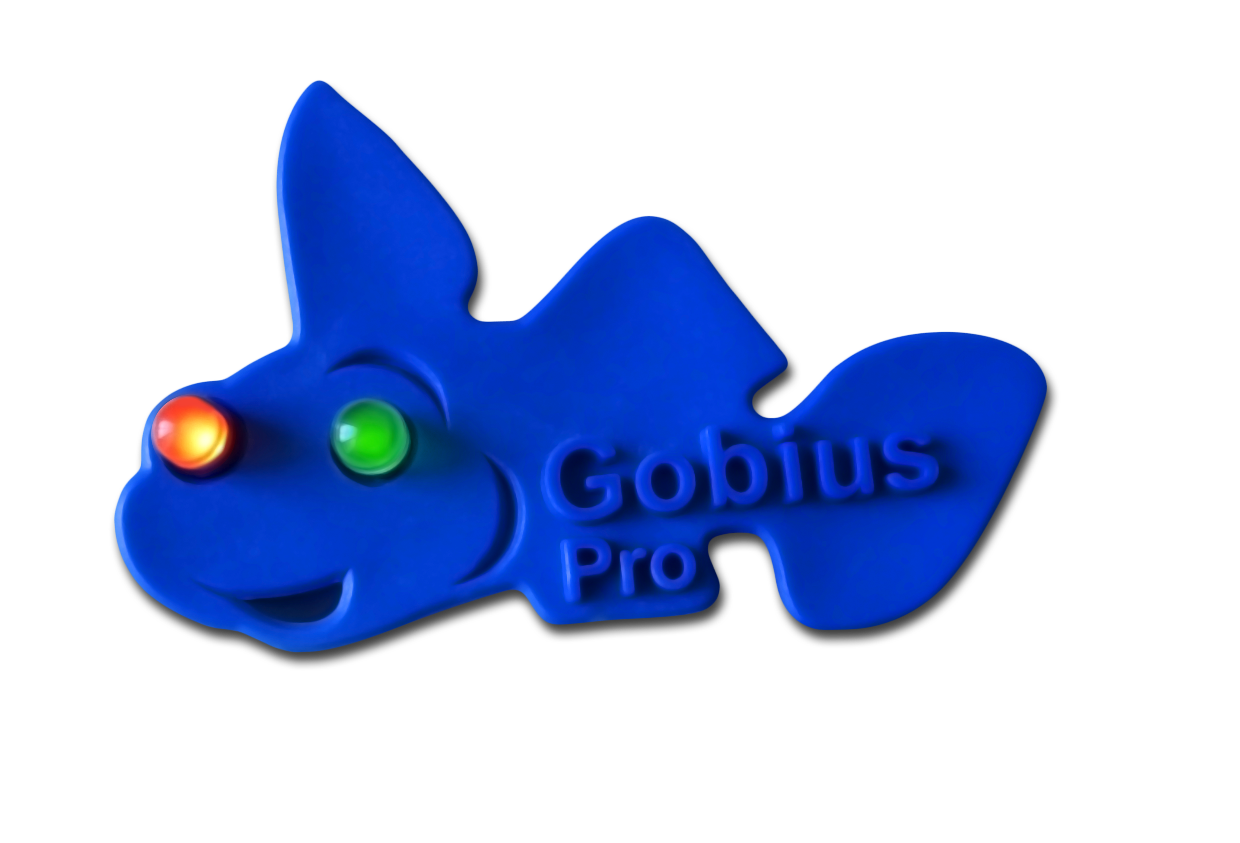
6a
Guide for you when you want to use the fish panel for your
black water tank.
Digital output 1:
Select, “On when the level is below the sensor”,
please connect the green cable + the red cable to the fish cables.
The green LED will light when the level is below the sensor.
Digital output 2:
Select, “On when the level is above the sensor"”,
please connect the yellow cable + the red cable to the fish cables.
The red LED will light when the level is above the sensor.

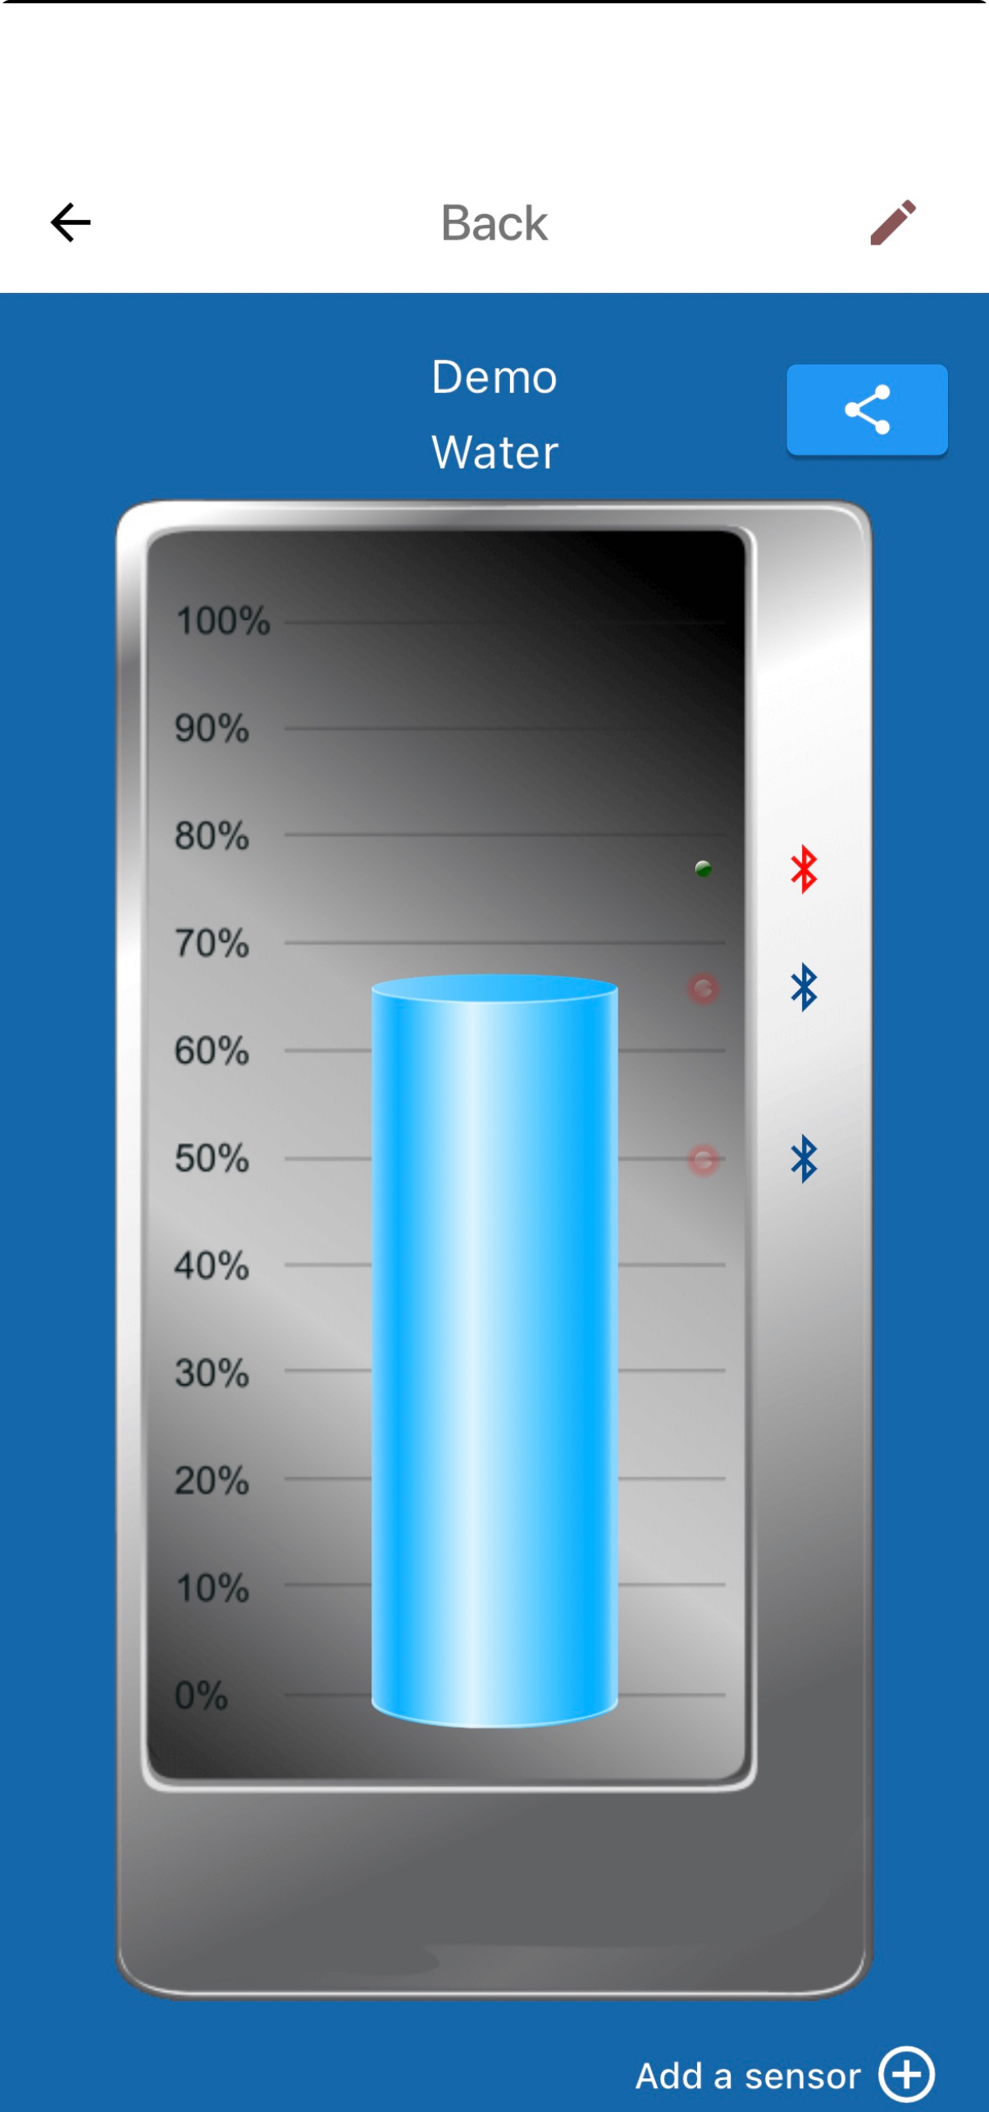
6b
On the Tank screen on your phone, you have some small icons:
- Edit functions
- Tank name and type of fluid
- Tip your friends
- Bluetooth icon = a sensor
- Red icon, no Bluetooth connection
- Blue icon, your phone is connected to the sensor
- The bar = the fluid level above two sensors
- Extra alarm when level is above the sensor = Red (if not = Green)
- If you like to add another sensor

6c
You can always make a new Calibration, as well as changing
settings like measurement period, names, digital outputs and
warning yes or no. Calibration is done for one-by-one sensor,
not all at once.
6c
About
- App version
- Name of the developers
- Share support data
- Security, integrity and guarantee

6d
Other information
- Instant Measure
Note: Create an extra measurement
- Remove the sensor
Note: Removes the sensor from the app
- Save
Note: Saves all settings in the sensor and the app
6e
Take your time to register your product
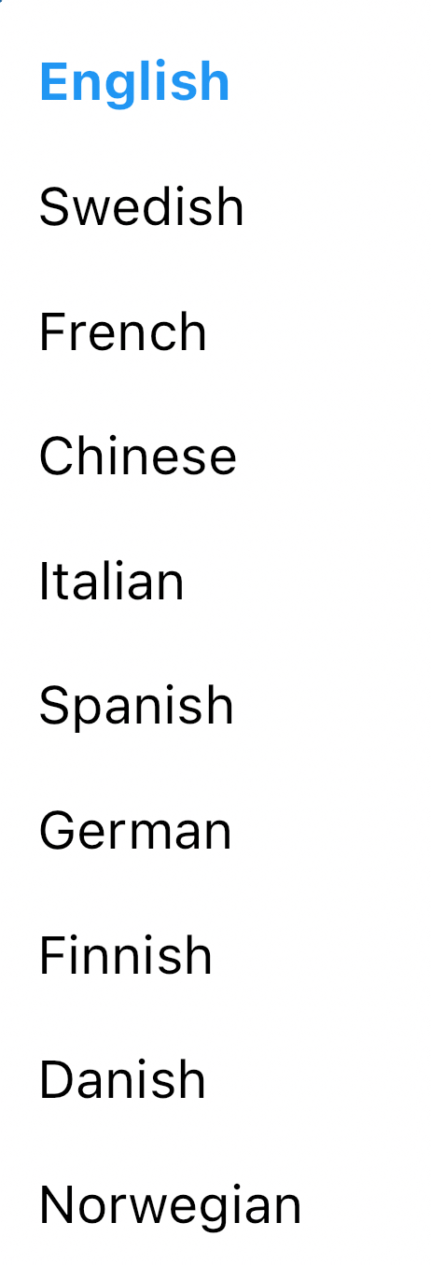
We offer all our customers free support, but the prerequisite is that the customer
registers their product on our site. This requirement is mainly so that we can then
effectively help our customers. We believe that you understand this requirement.
Welcome to register your product at,
https://www.gobius.se/en/support-2/product-registration
6f New features in version 3.5.2
- Place the sensor anywhere, e.g. 14%, 75%, or on another level
- Mount sensors in any order
- Choose from 10 available languages
- Name your tank and sensor
- Add personal notes to each sensor
- Lock and unlock sensors with a tap
- Share your tank data with friends (feature coming August 2025)
- Contact support directly through the app
- Manage both Gobius Pro and Gobius C in same app
6g
Sharing Tank settings (This will be available in end August 2025)
You will be able to share your settings with friends. The feature
is also useful when you get a new phone.

- Locked mode (no editing functions)
- Edit mode (all editing functions)

6h
If a title on the menu on your phone is in grey,
it means that you are not Bluetooth connected to your sensor.
6i
Sensor firmware older than 2.2.3, does not yet support this new app.

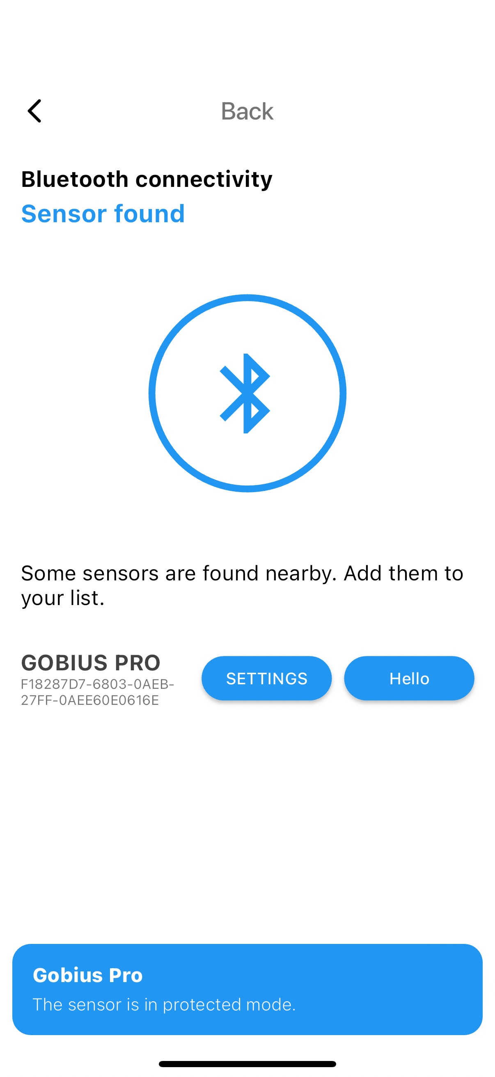
6j
Unlocking a sensor
If your sensor is locked with the old app or the new app,
follow these steps to unlock it.

- Go to this page in the App
- Click here 7 times quickly on Gobius Pro

Gobius Sensor Technology AB
Phone: +46 (0)31 650170
E-mail: info@gobiuspro.com
Gobius Sensor Technology AB develops and markets innovative products and solutions that create positive effects for boat owners and also for toilets on train. The products are easy to install, easy to use, reliable and are environmentally friendly. Gobius is marketed by distributors and dealers in 22 countries. The company started in 2008 and has launched products, which in an easy and effective way, from the outside of the tank, measure the level of waste, water, fuel and other fluid tanks. We have also received some awards in Sweden, Europe and USA. Patent/Trademarks: US 8.448.509, Sweden 0701520-9 and EU 2165164. Trademark Gobius, owned by Gobius Sensor Technology AB.
For further information, please visit www.gobiuspro.com.

